* **Prepaid Payments**

1. **Click Menu**
2. **Click Transaction**

Menu

1. **Click Prepaid Payments**

Transaction

Prepaid Payments

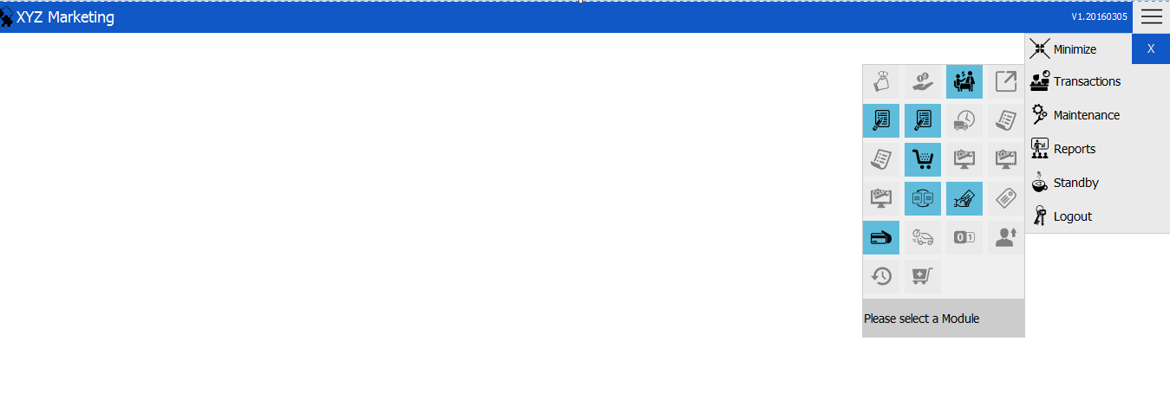

* **New Prepaid Payments Transaction**

1. **Search a customer**
2. **Input amount**
3. **Click Add**

Add

Amount

Customer’s Name

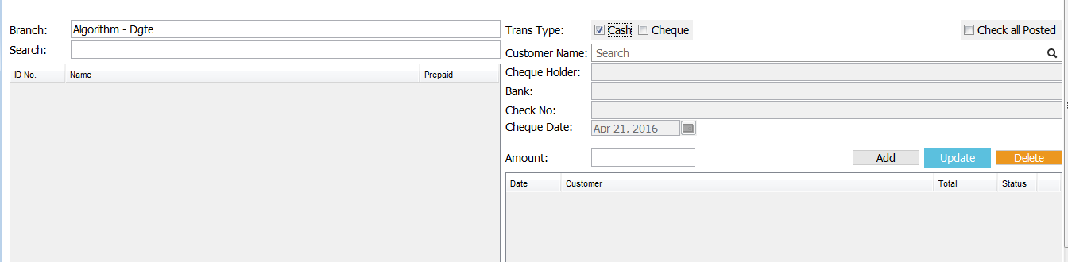

Update

Delete

**Note: Once you added a new transaction, it is still posted and needs to be finalized.**

* **Finalizing Prepaid Payment**

1. Just check the check box beside the status and then right click the transaction. Click Finalized.

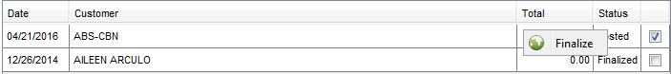

1. 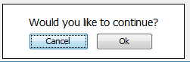A message dialog box will appear and just click OK.
2. This message dialog box will appear if you successfully finalized.